JESTERS PIE DAY – Friday 25 September
Place your Jesters Pie Fundraising Lunch order online through your Kindo account.

Step One: Login or Register

New users can click here to create an account. All you need is the email address our school has on file for you. You’ll then receive a link sent to this address to complete the sign up process!

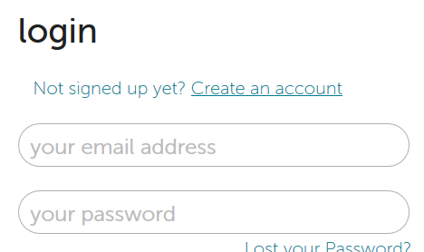
Already have an account?
Then simply login here with your email address and password.

Step Two: Place your order for Pie Day

Click on your child’s initial icon next to their chosen lunch item.
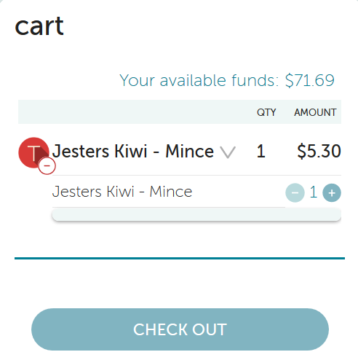
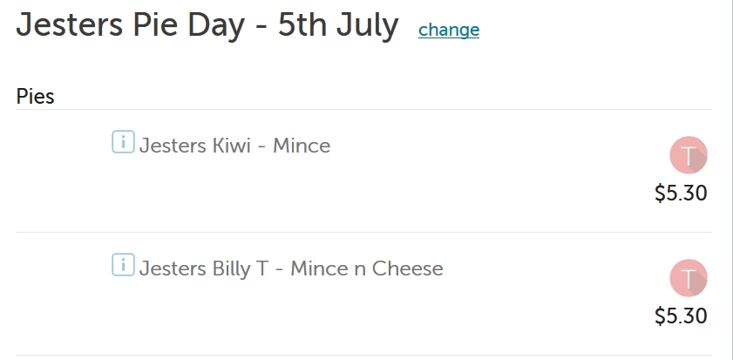

Their items will then display in your cart.

Step Three: Proceed to checkout and choose your payment method

POLi – No fees (until the end of term 2). Instant transfer. *Recommended*
Debit or Credit card – 2.5% +.50c fees. Instant transfer.
Bank Transfer – No fees. Allow two business days for transfer of funds.

Orders cut off at 11am on Thursday 24 September. Place your order before then to make sure your child doesn’t miss out!

If you need assistance call the Kindo helpdesk on free phone:
0508 4 KINDO (0508 454 636).

